Bicornuate Uterus

Student Name
Affiliation
Course Number, Course Name
Instructors Name
Due Date

04/12/2024

Bicornuate Uterus
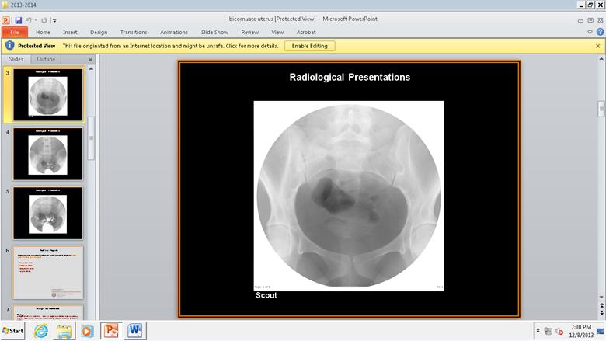
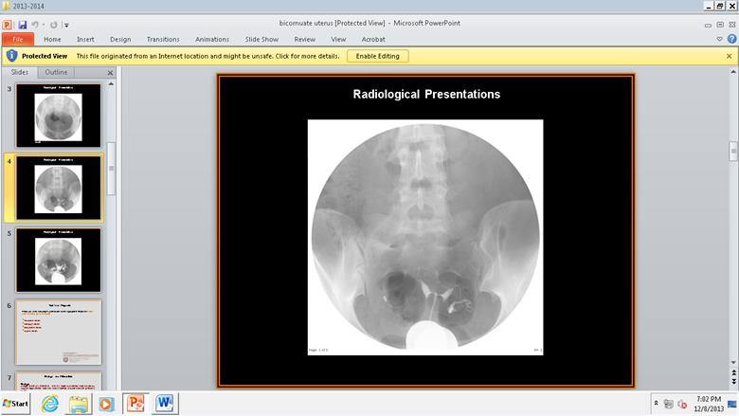
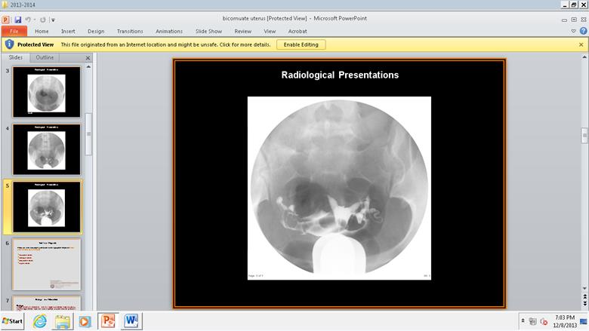

Location
Bicornuate uterus is a congenital uterine anomaly which is characterized by the presence of two separate uterine horns, each with its own cervix according to Dunivan et al. In these women, the dual-womb situation affects around 1 in Every 200 Cases. Such a kind of problem can become a big issue for fertility and pregnancy. In this case study about a 17-year-old female with fertility with a single cervix was visualize resulting in bicornuate. The bicornuate uterus is seen in the pelvic cavity in the given scans, in posterior of the rectum and anterior of the bladder. Two separate uterine horns (or cavities) can be distinguished on each side superiorly from single cervix. Not to mention its characteristic heart-shaped or bicornuate appearance. So, the exact orientation and location of the horns may vary slightly from person to person, but the presence of two distinct high uterine segments is characteristic of this condition. In addition, the bicornuate uterus is often associated with other congenital anomalies of the female reproductive system such as uterine septet or vaginal septum.
Radiographic Appearance
Radiographic imaging, such as hysterosalpingograms (HSGs), are often used to diagnose bicornuate uterus. During a HSG, contrast dye is injected into the uterus and fallopian tubes; its course can be seen and followed with X rays as Grimbizis suggests. The radiographic appearance of this bicornuate uterus in a human illustrates the characteristic shape typical of that organ. On the HSG images we observed a single cervix with the contrast dyed filling uterine cavity Then it divides into two separate upper uterine segments or horns. The bottom of the uterus is also split, generally taking on the shape of a heart or bicorn. The intercornual distance (displacement between the two horns) and intercornual angle (corner angle of the two uterine horns) being measured, a non-decreased intercornual distance with an intercornual angle greater than 60 degrees being suggestive of a bicornate uterus as explained by Ludwin et al. Furthermore, the anatomical appearances display no communication between the two dilated uterine horns, which are separated widely. The last image shows double uterine horn, filled with liquid contrast. This allows to visualize the curved form of the convex fundal contour of each horn with high accuracy. Magnetic Resonance Imaging (MRI) can be used to see the bicornuate uterus which is another excellent modality to visualize. On MRI, the cervix and uterine horns appear as distinct fluid-filled cavities, and they may have a hyperintense signal on T2 weighted images. The uterine myometrium (muscular layer of the uterus) would be hypointense rim around each horn. MRI gives an incredible soft tissue background image and the connection between the uterine horns and other pelvic structures is made very clear.
Causes
The exact cause of bicornuate uterus is not very clear, but it is believed to be a result of genetic factors or disruptions in the normal development of the uterus during embryogenesis. This is often due to the incomplete fusion of the Müllerian ducts during fetal, embryonic development. The Müllerian ducts are the structures that form the uterus, fallopian tubes, and upper part of the vagina in females. In normal development, the Müllerian ducts unite completely, and a single uterine cavity is formed. Incomplete fusion may result in the bicornuate uterus formation. During the period of critical Müllerian duct development and fusion, which happens in the time interval from 8th to 12th weeks of gestation, incomplete fusion is typically seen. It is usually there from the beginning and can be accompanied by other congenital abnormalities or reproductive problems like infertility or recurrent miscarriages as explained by Eisenberg. Nevertheless, the incomplete fusion of the two horns of the uterus on the above radiographic images has resulted in the formation of two separate uterine cavities.
Treatment
The treatment protocol for bicornuate uterus involves many facets like the severity and the symptoms of the condition and an individual's reproductive goals as stated by Ludwin et al. In cases where infertility or recurrent pregnancy loss is associated with this disease, surgical interventions like metroplasty will be considered. Metroplasty is a surgical operation that is performed to correct the uterine anomaly for the creation of a more normal uterine cavity, which promotes fertility chances and minimizes pregnancy risks. The surgery seeks to smooth out the two uterine horns in one cavity, possibly enhancing the probability of implantation of the embryo and carrying a pregnancy to its term. Surgery is mainly performed with laparoscopy or in a minimally invasive manner depending on the surgeon's choice and the complexity of the case according to Sherer et al. Moreover, in situations when partners are infertile, assisted reproductive technologies such as in vitro fertilization (IVF) may be the suggested procedure. IVF skips the need for the sperm to travel through the fallopian tubes and directly puts the embryo into the uterus hence, it is possible that it will result in high conception and successful pregnancy rate. In some situations, the treatment involves surgical intervention and application of assistive reproductive technologies that are tailored to the specific characteristics of the disease and the wishes of the patient. The most important thing here is a multidisciplinary team comprising of reproductive endocrinologists, surgeons and radiologists are able to take the best decision for an individual based on his circumstances and goals.
Final Report
Findings
A single cervix was visualized. There is a single lower uterine segment with two separate upper uterine segments. Normal spillage of contrast into the peritoneal cavity.
Diagnosis
The HSG findings of two cornua with non-decreased intracorneal distance and intracorneal angle of greater than 60 degrees were sufficient to diagnose a bicornuate uterus
References
Dunivan, Gena C., et al. “Gaining the Patient Perspective on Pelvic Floor Disorders’ Surgical Adverse Events.” Obstetrical & Gynecological Survey, vol. 74, no. 6, June 2019, pp. 336–37. https://doi.org/10.1097/ogx.0000000000000689.
Eisenberg, R. L., Johnson N.M. (2016). Comprehensive Radiography Pathology 6th. ELSEVIER.
Grimbizis, Grigoris. “Clinical Implications of Uterine Malformations and Hysteroscopic Treatment Results.” Human Reproduction Update, vol. 7, no. 2, Mar. 2001, pp. 161–74. https://doi.org/10.1093/humupd/7.2.161.
Ludwin A, Ludwin I, Martins WP, Nastri CO. Reproductive outcomes after surgical treatment of bicornuate uterus: a systematic review and meta-analysis. Arch Gynecol Obstet. 2019;300(1):1-11. doi:10.1007/s00404-019-05190-7
Raga, Francisco, et al. “Reproductive Impact of Congenital Mullerian Anomalies.” Human Reproduction, vol. 12, no. 10, Oct. 1997, pp. 2277–81. https://doi.org/10.1093/humrep/12.10.2277.
Sherer, David M., et al. “Noninvasive First-Trimester Screening for Fetal Aneuploidy.” Obstetrical & Gynecological Survey, vol. 52, no. 2, Feb. 1997, pp. 123–29. https://doi.org/10.1097/00006254-199702000-00021.

